VARIE – ASHxxx  MISCELLANEOUS – ASHxxx | DERIVATORI  SHUNTS
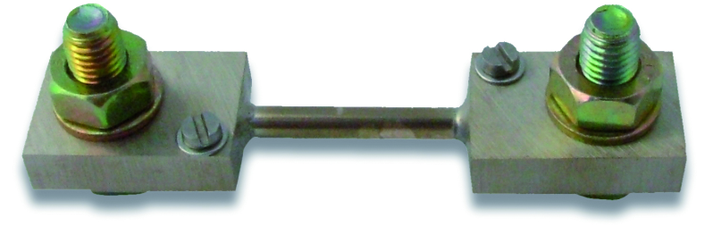 |  |   

DESCRIZIONE | DESCRIPTION
Derivatori per la misura di corrente continua.  Uscita di 60 oppure 100 mV | Shunts for measuring direct currents.  Output of 60 or 100 mV

SPECIFICHE TECNICHE | TECHNICAL SPECIFICATIONS
Realizzati in manganina  Montaggio su basetta isolata fino a 60 A  Finitura: trattamento al nichel  Dissipazione: 0,6 W/A  Sovraccarico: 1,2 In, permanente  10 In, per 5” ( fino al modello ASH250)  5 In, per 5” (modelli superiori)  Uscita in mV: su vite M4 con rondelle  Prese di corrente: fino a 60 A con bulloni M6  oltre 60 A con bulloni M10  Note: su richiesta realizzazioni da 1 a 6000 A | Made of manganin  Mounting on isolated base for current up to 60 A  Finish: nickel plating  Dissipation: 0.6 W/A  Overload: 1.2 ln, continuous operation  10 In, for 5” (up to ASH250 model)  5 In, for 5” (upper models)  mV output: on M4 screw with washers  Current input: up to 60 A with M6 bolts  from 60 A and above with M10 bolts  NOTE: on request custom devices from 1 to 6000 A

 |  |  |  |  | Dimensions (mm)
Codice  Code | Portata  Capacity | Caduta di tensione  Voltage drop | Classe  Class | Fig. | A | B | C | D | F
ASH006 | 6 A | 60 mV | 0.5 | 1 | --- | --- | --- | --- | ---
ASH010 | 10 A | 60 mV | 0.5 | 1 | --- | --- | --- | --- | ---
ASH025 | 25 A | 60 mV | 0.5 | 1 | --- | --- | --- | --- | ---
ASH060 | 60 A | 60 mV | 0.5 | 1 | --- | --- | --- | --- | ---
ASH100 | 100 A | 60 mV | 0.5 | 2 | 10 | 36 | 86 | 112 | 25
ASH101 | 100 A | 100 mV | 0.5 | 2 | 10 | 36 | 114 | 138 | 25
ASH151 | 150 A | 60 mV | 0.5 | 2 | 10 | 38 | 86 | 112 | 25
ASH250 | 250 A | 60 mV | 0.5 | 2 | 10 | 38 | 86 | 112 | 25
ASH400 | 400 A | 60 mV | 0.5 | 2 | 10 | 40 | 86 | 117 | 38
ASH600 | 600 A | 60 mV | 0.5 | 3 | 20 | 60 | 131 | 173 | 48

